**PRE- MOCK SET 5 EXAMINATIONS, 2024**

**PRIMARY SEVEN MATHEMATICS**

**Duration: 2 Hours 15 Minutes**

**NAME: ______________________________________________ STREAM: _________**

INDEX NO.

EMIS NO.

|  |  |  |  |  |  |
| --- | --- | --- | --- | --- | --- |
|  | Multiply; 1 3  × 2 |  | | Find the next numerals in the sequence below;  81, 64, 49, 36, ………, …….. | |
|  | Write; eighteen thousand eighteen in figures. |  | | Find the circumference of a circle whose diameter is 14cm. | |
|  | Solve for h: 3(h-6) = 0 | |  | Simplify; 7 + **-**7. | |
|  | There were 1500 pupils in a school last term. The population grew by 20% this term. How many pupils are there this term? | | 1. 1 | Find the range of 4, 0, 6 and 3. | |
|  | Using a ruler, a pencil and a pair of compasses, bisect the acute angle OPM. | | 1. 1 | Simplify; (3×5**2**) + (4×5**0**) | |
|  | A football match that lasted 1 hours ended at 6:40pm. At what time did it start? | |  | A motorist covered 144km in 2hours. Claculate his speed in metres per secod. | |
|  | Divide 30 by 0.6. | |  | Write LXX in Hindu-Arabic numeral. | |
|  | Simplify; 2-3(2-3) | |  | Calculate the simple earned on a fixed bank deposit of sh.120,000 at a rate of 3& p.a for 3years. | |
|  | Find the square root of 36. | |  | | Simplify; |
|  | If p×q = 2q-p, find the value of 2×4. | |  | | Paul was standing in a line of boys such that he was the 12th from one end and 18th from the other end of the line. How many boys were in that line? |

**SECTION B**

1. Peter scored the following marks in a series of tests; 75, 90, 86, 75, 81 and 79.
2. Find the total mark (1mrk)
3. What is the median mark? (2mrks)
4. Work out Peter’s mean score. (2mrks)
5. Below is a venn diagram showing the number of boys who like mangoes(M) and passion fruits(P). Use it to answer the questions that follow.

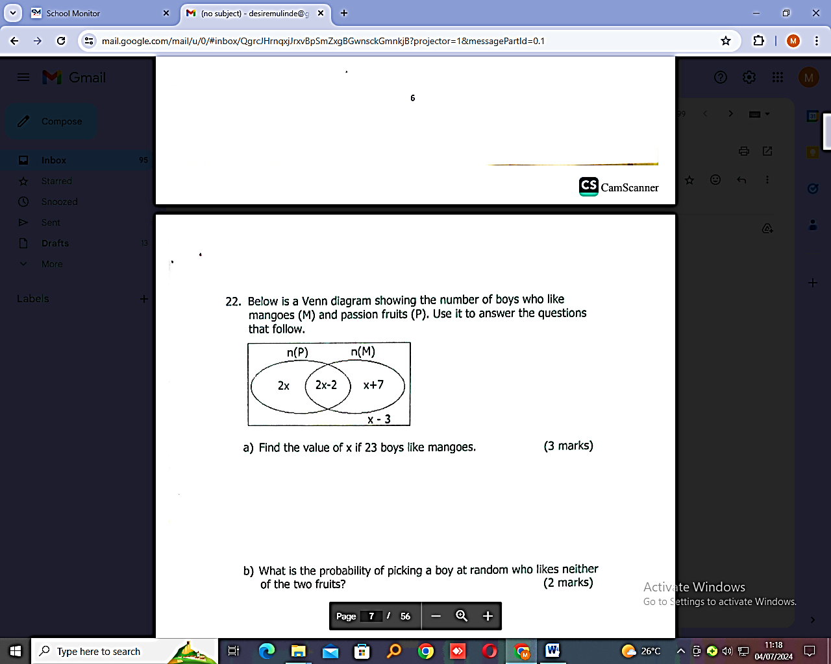

1. Find the value of x if 23 boys like mangoes. (3mrks)
2. What is the probability of picking a boy at random who likes neither of the two fruits? (2mrks)
3. a) The book shelves in a library can carry 240 books at 60 books per shelf. How many shelves are needed to carry 420 books? (2mrks)

b) A taxi carrying 8 adults and 4 children left new taxi park heading to Mukono. If each adult and each child paid a fee of sh.5000 and sh.3000 respectively, how much money did the driver collect in total? (3mrks)

1. a) Using a ruler, a pencil and a pair of compasses, construct a triangle ABC where AB= 8cm, ABC=60**0** and BAC = 450. Drop a perpendicular line from point C to meet line AB at N. (4mrks)

b) Measure angle ACB. (1mrk)

1. a) Solve the inequality; 5m-3 > 7(m+1) (2mrks)

b) Kevin is 12years old now and her friend Kathy s 27years. After how many years will Kathy be twice as old as Kevin? (3mrks)

1. Below are flash cards having different digits as shown. Use them to answer the questions that follow.

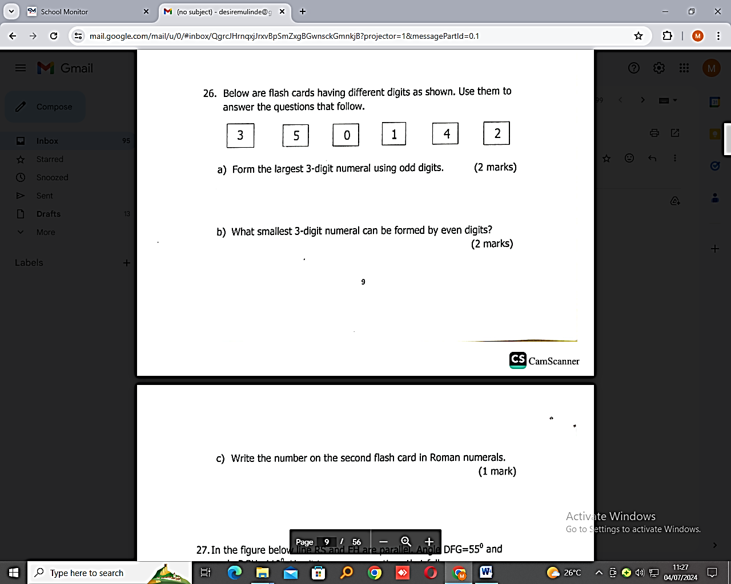

1. Form the largest 3-digit numeral using odd digits. (2mrks)
2. What smallest 3-d-g-t numeral can be formed by even digits? (2mrks)
3. Write the number on the second flash card in Roman numerals.
4. In the figure below, line RS and FN are parallel. Angle DFG = 55**0** and angle DGH=110**0**. Use it to answer questions that follow.

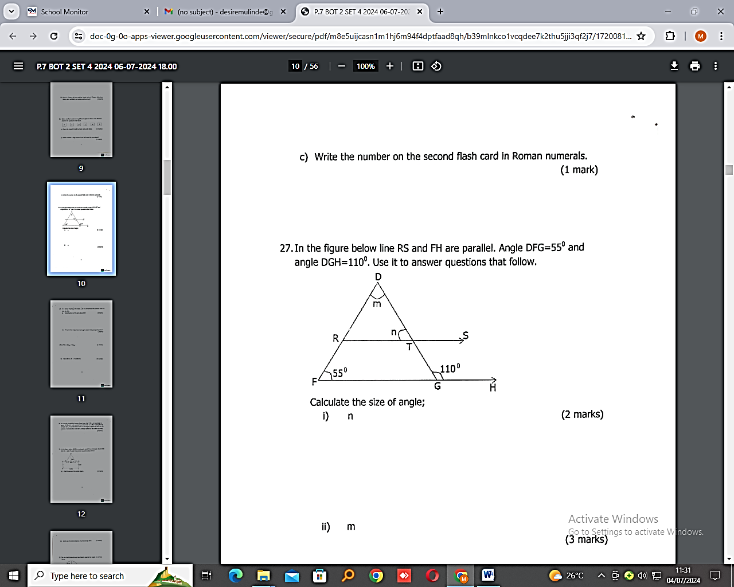

Calculate the size of angle;

i) n (2mrks) ii) m (3mrks)

1. In a group of girls, like chips, of the remainder like chicken and the rest like fish.
2. What fraction of the girls like fish? (3mrks)\
3. If 5 girls like chips, how many girls are in that group altogether? (2mrks)
4. a) Add; 132**four** + 21**four**. (2mrks)

b) Solve for k; 2k = 4 (finite 5) (3mrks)

1. A motorist started his journey from town A at 7:30am moving at a speed of 60km/hr and reached town B at 9:30am. After resting for 3o minutes at B, he continued to town C moving at a speed of 70km/hr for 1 hours. Calculate the motorist’s average speed for the whole journey. (5mrks)
2. In the figure below ABCD is a rectangle and EFG is a triangle. Given that line DC = side FG. Use it to answer questions that follow.

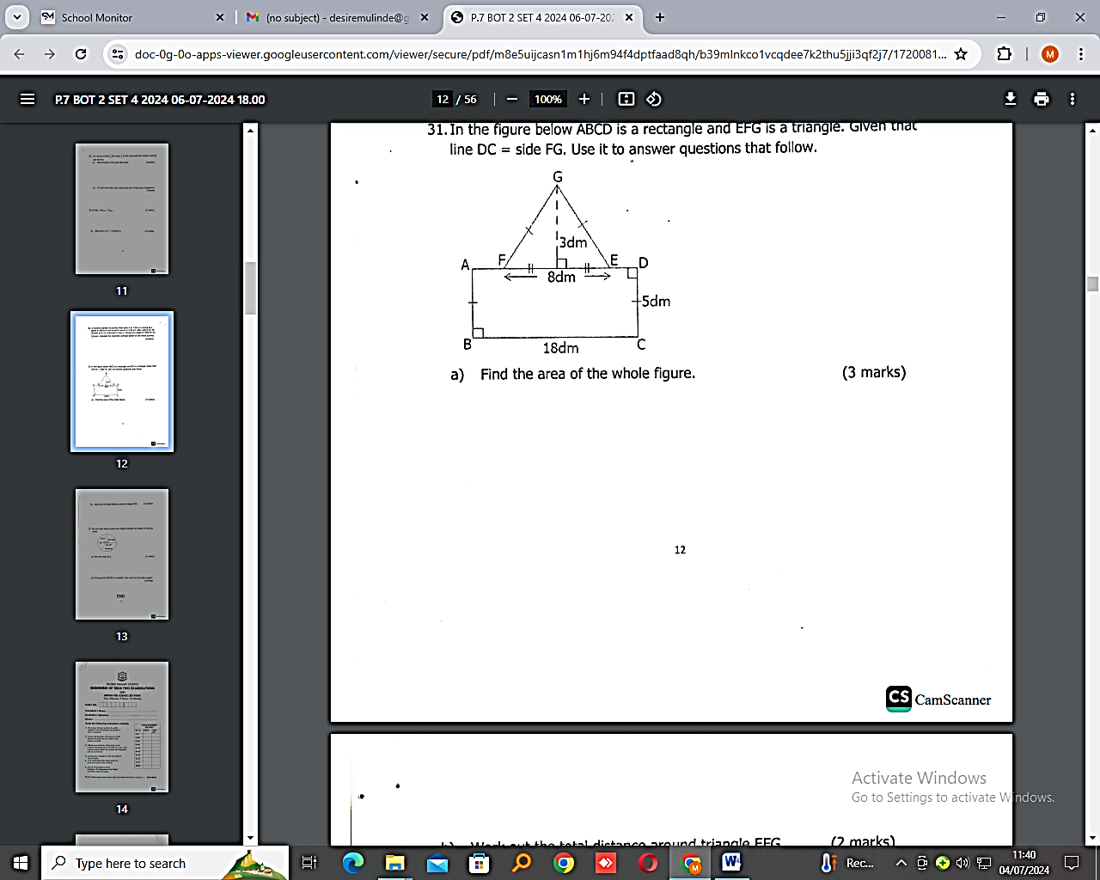

1. Find the area of the whole figure. (3mrks)
2. Work out the total distance around triangle EFG. (2mrks)
3. The pie-chart below shows how Okecho spends his wages on various items.

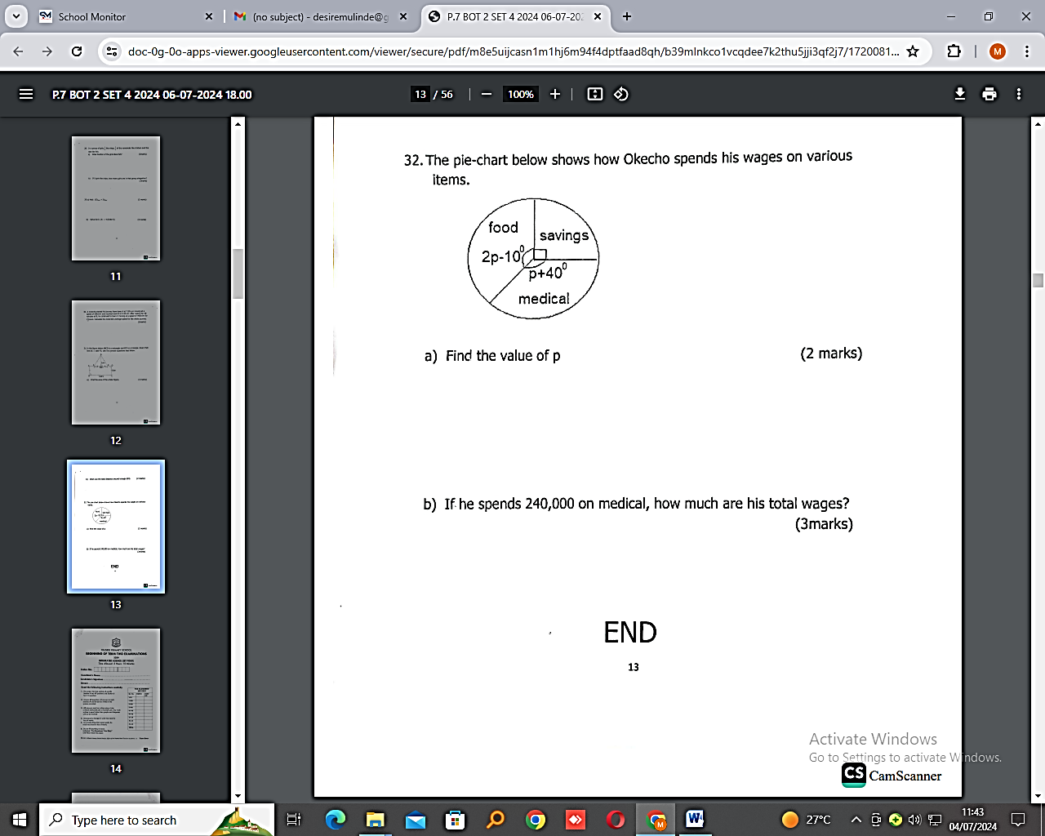

1. Find the value of p. (2mrks)
2. If he spends 240,000 on medical, how much are his total wages? (3mrks)

**END**